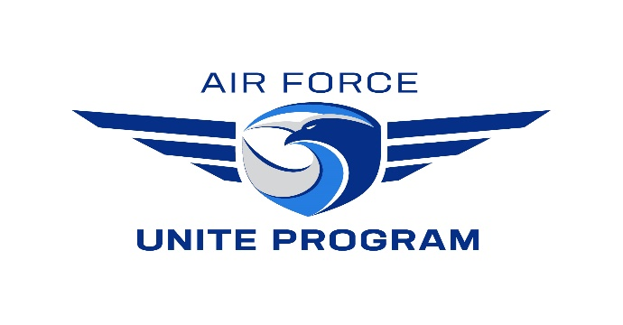
(ENTER DATE HERE)

MEMORANDUM FOR COMMUNITY COHESION COORDINATOR

FROM: (ENTER YOUR SQUADRON HERE)

SUBJECT: Letter of Appointment
Squadron Unite Program Point of Contacts (POCs)

- The following personnel are appointed Primary and Alternate Squadron Unite Program POCs for the (ENTER YOUR SQUADRON HERE)

 | Grade | Name | Email Address | Duty Phone
Primary
Alternate

- The POC(s) will agree to comply with the following requirements:

  - Contact the installation Community Cohesion Coordinator (C3) to discuss the proposed squadron
event and authorized expenses.

b. Complete an Event Proposal Form provided by the installation C3 (Downloadable form available
at 374fss.com/UNITE) and forward to the UNITE org box (374fss.fsbu.uniteprogram@us.af.mil)
30 days (recommended), but NLT 14 days (required) in advance of requested event – This is to
allow AFSVC time to review/approve event request.

c. Ensure that event requests are for bonifide UNITE events and not for unauthorized events (ie.
Holiday Parties, Balls, Banquets, Dining In/Out Functions, etc) Please vist UNITE website at
374fss.com/UNITE for details.

d. Ensure budget limits are maintained at all times (NAF food and beverage = $5 per person and APF
program costs = $13.50 per person).

e. Provide C3 with After Action Report plus minimum of 2-3 action photos of personnel enjoying the
event within two business days after every event.

(Signature Here)

Squadron Commander Rank/Title

